Functional Safety Concept
Project name: MVC SOW2
Version: A01
Status: Draft
Date: 19.11.2024
Author: O. Jaeschke

Printed copies of this document are not subject to document control!
Table of Contents
1. General information 7
1.1 Purpose of this document 7
1.2 Scope 7
2. Item definition 8
3. Hazard analysis and risk assessment report 9
4. Safety goals 9
4.1 Fault tolerance time & system transition to safe state 10
4.2 Functional safety Requirements given by Volvo 10
5. Goal Structuring Notation 14
5.1 Goal Structuring Notation for Safety Goal SG1 (Latency) 14
5.1.1 SG1 (Latency) – Image Acquisition – Data and Control Path 15
5.1.2 SG1 (Latency) – Image Processing – Data and Control Path 16
5.1.3 SG1 (Latency) – Image Output – Data and Control Path 17
5.2 SG1 – Functional Safety Requirements 17
5.3 Functional GSN – Safety Goal SG2 (Live, not frozen) 19
5.3.1 SG2 (Live, not frozen) – Image Acquisition – Data and Control Path 20
5.4 SG2 – Functional Safety Requirements 20
5.5 Functional GSN – Safety Goal SG3 (Szene) 20
5.5.1 SG3 (Scene) – Image Acquisition 22
5.5.2 SG3 (Scene) – Image Processing 22
5.5.3 SG3 (Scene) – Image Output 23
5.6 SG3 – Functional Safety Requirements 23
5.7 Functional GSN – Safety Goal SG4 (Angle of view) – ASIL B 23
5.7.1 SG4 (Angle of view) – Image Acquisition – Data and Control Path 23
5.7.2 SG4 (Angle of view) – Image Processing – Data and Control Path 23
5.7.3 SG4 (Angle of view) – Image Output – Data and Control Path 24
5.8 SG4 – Functional Safety Requirements 24
6. Global Requirements 25
6.1 Functional GSN – Power 25
6.1.1 Power Monitor 25
6.1.2 Temperature Monitor 25
6.1.3 Clock Monitor 25
6.2 Functional GSN – Diagnosis 25
6.3 Functional GSN – Ethernet, SOME/IP 25
6.4 VOLVO – FSRs 25
7. Safe State 26
7.1 Fault Detection 26
7.2 Fault Reaction 26
7.3 Enter Safe State 26
7.4 Definition Safe State 26
8. System Architecture 28
8.1 Basic System Architecture 28
8.2 SNx Mapping to System Elements 28
8.3 Fault tolerance time & system transition to safe state 28
8.4 Degradation of Functionality 28
8.5 Leaving the Safe State 28
9. Technical Safety Requirements 29

List of figures
Figure 1: ISO 26262 7
Figure 2: Item definition 8
Figure 3: Hierarchy of safety goals and functional safety requirements 9
Figure 4: Fault Reaction Time Interval 10
Figure 5: GSN for Safety Goal SG1 (Latency) 14
Figure 6: GSN for SG1– Image Acquisition – Data and Control Path 15
Figure 7: GSN for SG1 – Image Processing – Data and Control Path 16
Figure 8: GSN for SG1 – Image Output – Data and Control Path 17
Figure 9: Fault tolerance time 19
Figure 10: Fault tolerance time 20
Figure 11: Fault tolerance time 21
Figure 12: Fault tolerance time 22
Figure 13: Fault tolerance time 22
Figure 14: Fault tolerance time 23
Figure 15: Basic System Architecture 28
Figure 16: Fault tolerance time 28

List of tables
Table 1: Change History 6
Table 2: Releases 6
Table 3: Template Version 6
Table 4: Authors 6
Table 5: Referenced Documents 6
Table 6: List of Abbreviations 6
Table 7: Functional Safety Requirements for Safety Goal 1 18
Table 8: Functional Safety Requirements for Safety Goal 2 20
Table 9: Functional Safety Requirements for Safety Goal 1 23
Table 10: Functional Safety Requirements for Safety Goal 1 24

Change history
Ver. | Author | Description / Change / Comments | Date
A01 | Oliver Jaeschke | 1st draft | 21/10/2023
A02 | Oliver Jaeschke | Changed text an picture in sec. 2;
Table 1: Change History
Releases
Ver. | Created / Date | Signature | Approved / Date | Signature | Released / Date | Signature
Table 2: Releases
Template history
Ver. | Created / Date | Signature | Approved / Date | Signature | Released / Date | Signature
A | 23.06.2020 | {S.Schuetz} | 24.06.2020 | {O.Jaeschke} | 25.06.2020 | {S.Schuetz}
B | 27.08.2021 | {O. Jaeschke} | 27.08.2021 | {S.Schuetz} | 27.08.2021 | {S.Schuetz}
C | 11.01.2022 | {O. Jaeschke} | 18.02.2022 | {S.Schuetz} | 18.02.2022 | {S.Schuetz}
Table 3: Template Version
Authors
Section | Name | E-Mail | Telephone
All | Oliver Jaeschke | Oliver.jaeschke@solectix.de | +49 (0) 911 - 30 91 61 - 292
Table 4: Authors
Referenced documents
No. | Title & Description | Version | Author | Link
[1] | ISO 2626 | 2018 | Multiple | S:\opendocs\spezifikationen\Normen\FuSi\ISO 26262-2018
[2] | Rear and Trailer Camera TR – 24548584 | v1 | Volvo Trucks Corporation | D:\ENTWICKLUNG\MEKRALang\MVC-SOW2\acquisition\technical_requirements\Requirements SOW2 für SX.zip
Table 5: Referenced Documents
List of abbreviations
Abbreviation | Description
CPU | Central processing unit
FPGA | Field Programmable Array
FDTI | Fault Detection Time Interval
FHTI | Fault Handling Time Interval
FRTI | Fault Reaction Time Interval
G | Goal
GSN | Goal structuring notation
MCS | Mirror camera system for replacing glass mirrors
SG | Safety goal
SN | Solution
Table 6: List of Abbreviations

General information
This document describes the functional safety concept for the project MVC SOW2 of the customer MEKRA Lang according to the guidelines described in ISO 26262-3:2018, Annex B [1]. Subject of this project is the development of a camera-monitor system for trucks. For more details about the project please read the project manual.

Purpose of this document
This document shall provide an overview on the functional behavior of the developed item in accordance with its safety goals and the constraints regarding suitable and timely detection and control of relevant faults. It further specifies the item level strategies or measures to achieve the required fault tolerance or adequately mitigate the effects of relevant faults by the item itself, by the driver or by external measures. The functional safety requirements are allocated to the system architectural design (or to external measures). Finally, it specifies the safety validation criteria.

Scope
This document describes the necessary measures and components in order to ensure functional safety according to ISO 26262 in the project MVC SOW2 – with the focus on the concept phase. Other norms and regulations relevant for camera monitor systems in road vehicles out of scope.

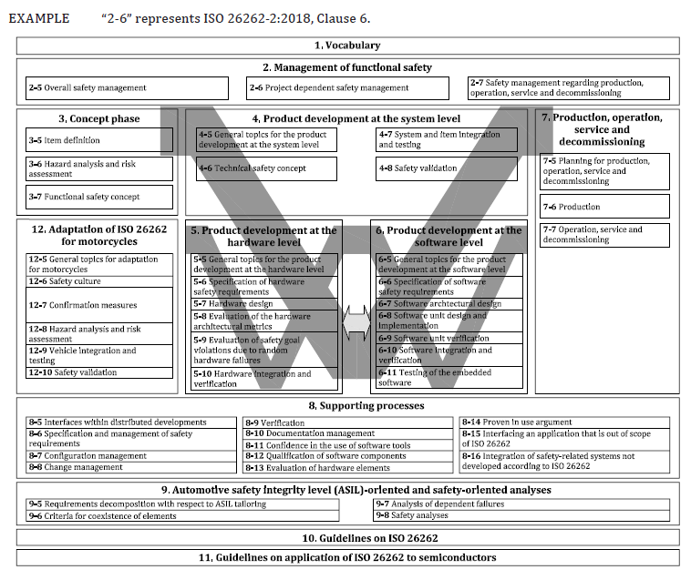
Figure 1: ISO 26262

Item definition
The item is an image processing-system and shall be used in road vehicles, in order to replace the glass mirror. It consists of an image capturing device, an image processing unit (for generating the required fields of view) and an Ethernet connector to send the image data to display panel for image output. It is also equipped with a diagnosis interface and needs electrical power. The following operating modes are possible (at least): off, start-up, normal operation, safe state;

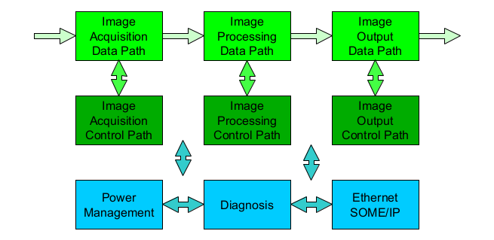
Figure 2: Item definition
Note 1: Figure 2 only shows the functional blocks and their connections relevant for functional safety.
Note 2: The connections between shown blocks shall not be able to store any data.
Note 3: Data Path of Image Acquisition is a deserializer input.
Note 4: Data Path of Image Output is an Ethernet Connector.

Note 5: The connections (arrows) between the blocks must also be considered…
- There is probably no link between IA Control Path and IP Control Path.
- There is probably no link between IP Control Path and IO Control Path.
- The connections in the Data Path shall not be able to store any data.
- The connections between Data Path and Control Path shall not be able to store any data.
- The connections between Data Path and Control Path shall be secured (e.g CRC, frequent checks of the configuration values).

TODO:
[01] Rear and Trailer Camera TR - 24548584 v1.pdf
Kapitel 13.2.1.1 Video Transmission -Timing Test

Hazard analysis and risk assessment report
The Hazard analysis and risk assessment report lies in the responsibility of the OEM, Volvo.

Safety goals
The following safety goals have been derived from the requirement specification from VOLVO ([01] Rear and Trailer Camera TR - 24548584 v1 (Chapter 13.2):

SG 1 (Latency): The system shall avert showing a delayed traffic situation in its video output at any time. The maximum delay shall not exceed 50ms. (ASIL C) [see REQ 24548584-71 v1] – FHTI: 400ms

SG 2 (Live, not frozen): The system shall avert a frozen image. (ASIL B)

SG 3 (Unclear view): The system shall display the environment realistically at any time regarding contrast and brightness, to avoid losing any detail, which could end up in a hazard.
Video frames causing an unclear view (too dim, too low contrast, too much disturbances or noise, wrong resolution, flicker, too low frame rate) shall not be transmitted (ASIL A)

SG 4 (Angle of view): The system has to show the correct angle of view, zoom factor and visual field at any time, to ensure that no important detail vanishes in a blind spot. (ASIL B).

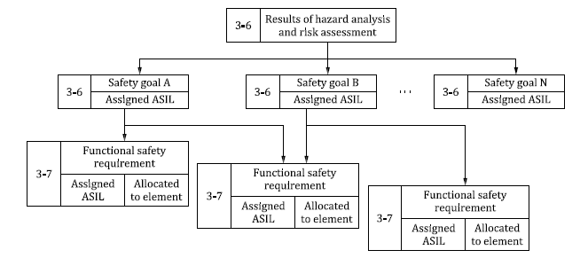

Figure 3: Hierarchy of safety goals and functional safety requirements

Fault tolerance time & system transition to safe state
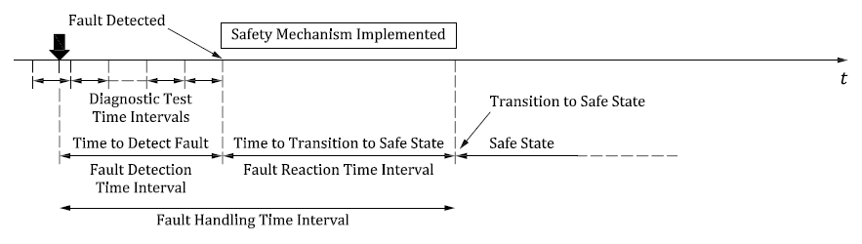
Figure 4: Fault Reaction Time Interval

As stated in REQ 24548584-71 v1 provided by Volvo, the maximum delay in standard operation shall be 50ms.
REQ 24548584-76 v1 further states that Fault Handling Time Interval (FHTI) shall be 400 ms.
The worst case consideration (time and location of the fault occurrence) of Fault Handling Time Interval results in: 400 ms – 50 ms = 350 ms

The FHTI for the whole SOW2 system (Image Acquisition, Image Processing, Image Output ) equals 350 ms. This value will be called FHTI (SOW2) in this document.

Assumption:
FDTI (SOW2) = 116 ms (1/3 FHTI (SOW2))
FRTI (SOW2) = 234 ms

Functional safety Requirements given by Volvo
Information

Requirements in this section is on System Level. System in this section refers to: Image acquisition in Sensor + Image transfer to ISP + Image processing in ISP + Image compression (e.g. to H.264/H.265) + Sending compressed image on physical layer (Ethernet/WiFi/etc.)
Camera supplier in this TR is fully responsible for that these system requirements are fulfilled

ID | Title | Description | ASIL | Comment
REQ 24548584-71 v1 | Video Transmission | Video frames shall be transmitted within 50 ms from actual traffic situation. | QM
REQ 24548584-72 v1 | Delayed video frame handling | Delayed Video frames older than FHTI (see REQ 24548584-76) from actual traffic situation shall not be transmitted | C
REQ 24548584-73 v1 | Frozen video frame handling | Frozen Video frames older than FHTI (see REQ 24548584-76) from actual traffic situation shall not be transmitted. | B / C ?
REQ 24548584-74 v1 | Video frames causing an unclear view | Video frames causing an unclear view (too dim, too low contrast, too much disturbances or noise, wrong resolution, flicker, too low frame rate) shall not be transmitted. | B / C ?
REQ 24548584-75 v1 | Video frames presenting wrong field of view | Video frames presenting wrong field of view (eg cropped/partial images) not easily detected by the driver shall not be transmitted | B / C ?
REQ 24548584-76 v1 | Fault Handling Time Interval (FHTI) | Fault Handling Time Interval (FHTI) shall be 400 ms | C
REQ 24548584-77 v1 | Safe state | Detected faults for any FuSa requirement shall trigger a transition to a Safe state.  Safe state is defined as halted image transmission. | C
REQ 24548584-78 v1 | Operating in safe state | In safe state, the camera shall attempt to recover from safe state and transition back to normal operation if none of the FuSa requirements are violated | QM
REQ 24548584-79 v1 | Integrity of received images | Video frames shall be transmitted such that it is possible to check integrity of received images | B
Table 7: FSCs from Volvo

Functional Safety Requirements Derived from Safety Analysis

ID | Title | Description | ASIL | Comment

Goal Structuring Notation
This chapter addresses the functional aspects of the system and uses the Goal Structuring Notation (GSN) framework to clarify the hierarchy, goals, strategies, and initial solutions (SNx) that ensure operations.

Goal Structuring Notation for Safety Goal SG1 (Latency)

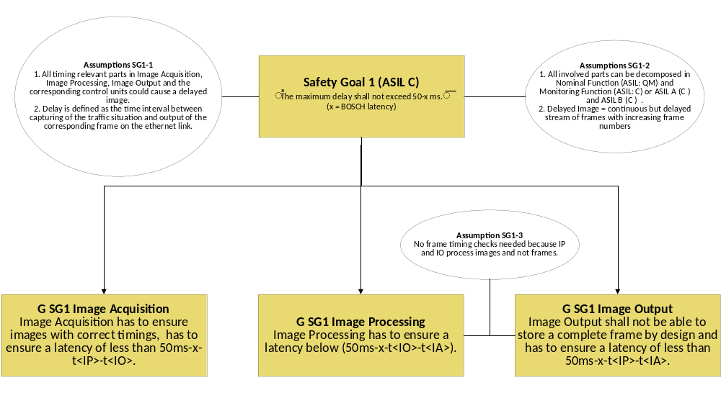
Figure 5: GSN for Safety Goal SG1 (Latency)

TODO:
- “x” has to be eliminated
- “not be able to store a complete frame” must agree with the architecture.
- Global Safety Mechanism (time stamp, …) shall be integrated in GSn

Explanation:
t<IO> = delay caused by Image Output
t<IA> =delay caused by Image Acquisition
t<IP> = delay caused by Image Processing

SG1 (Latency) – Image Acquisition – Data and Control Path

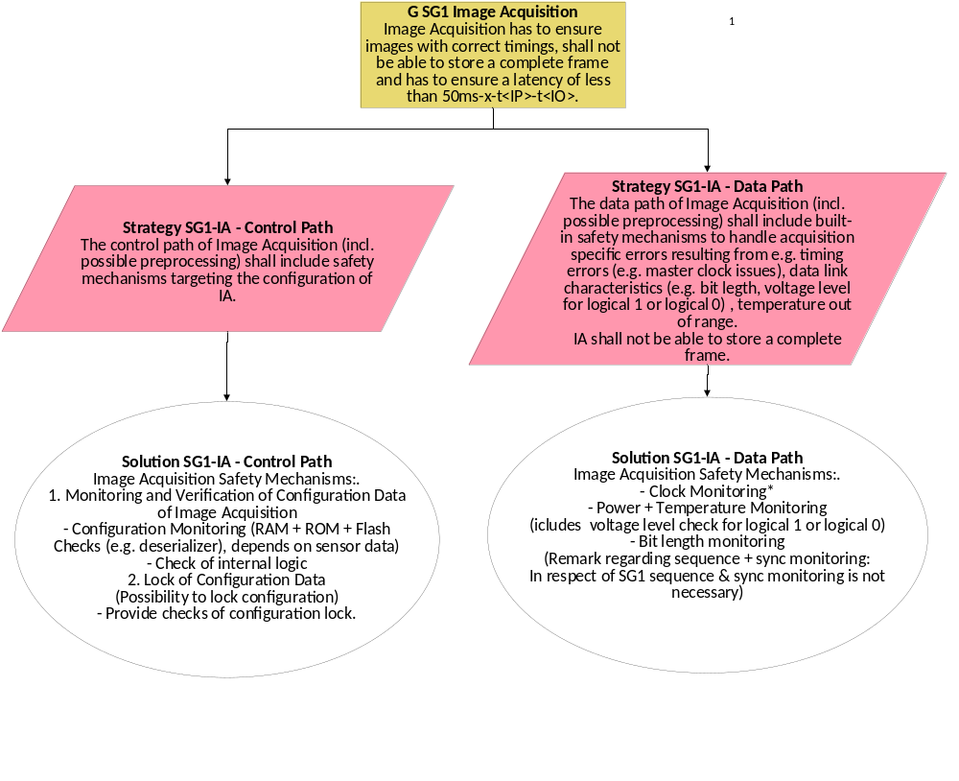
Figure 6: GSN for SG1– Image Acquisition – Data and Control Path

SG1 (Latency) – Image Processing – Data and Control Path

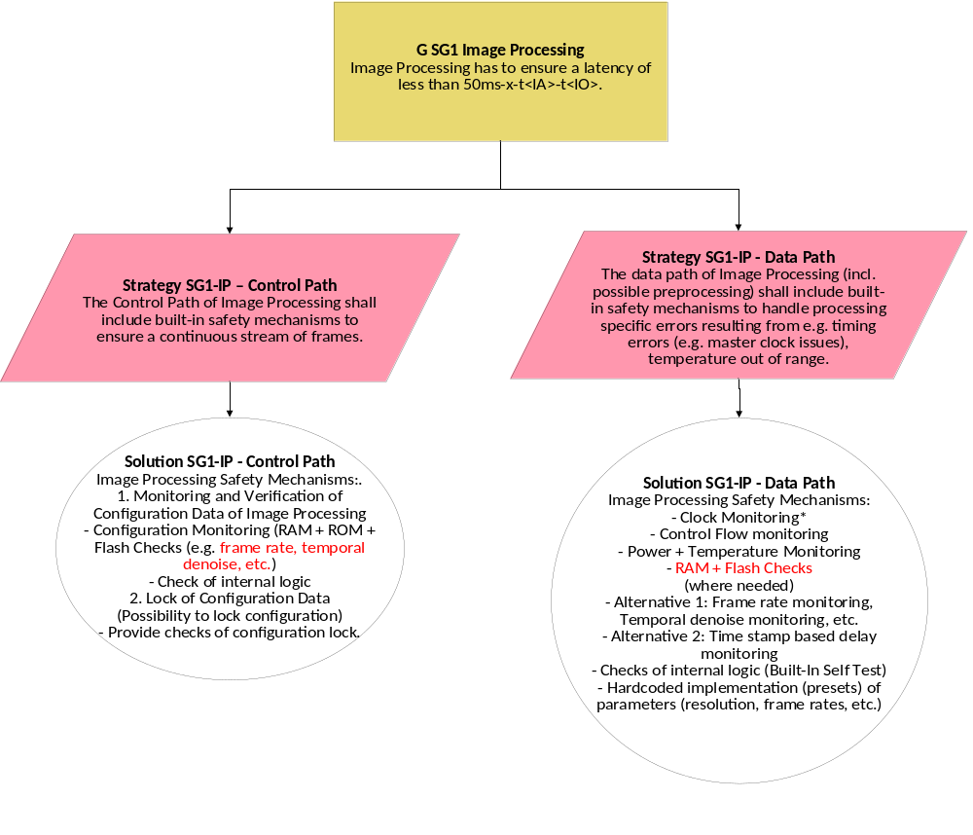
Figure 7: GSN for SG1 – Image Processing – Data and Control Path

*: ASIL assignment/FIT rate shall be given by the manufacturer.
Red: To be clarified with Ambarella

Control path was missing, because…

SG1 (Latency) – Image Output – Data and Control Path
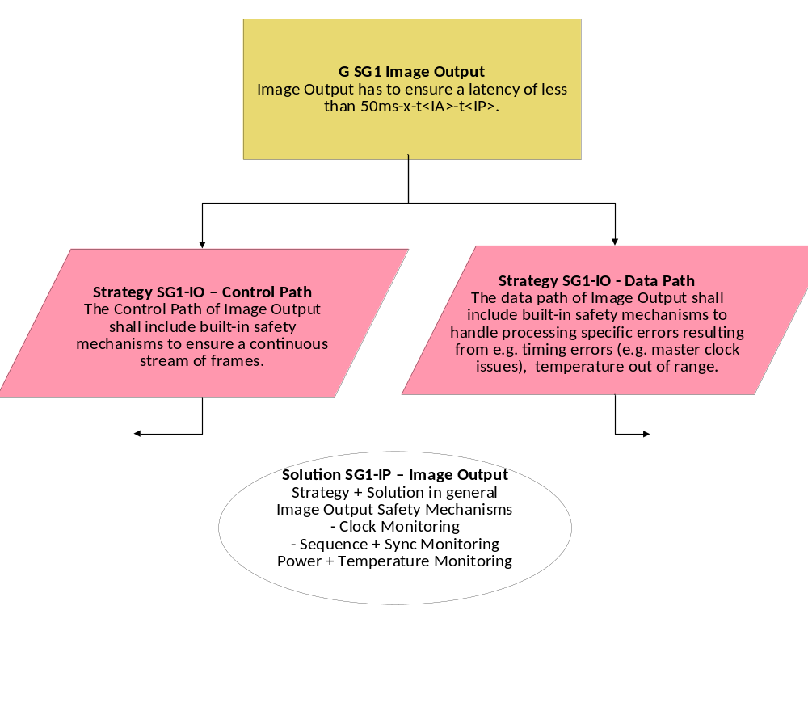
Figure 8: GSN for SG1 – Image Output – Data and Control Path

Agreement: Image Output stage consists of Time Stamp Manager (ASIL C (C)) and H264 stage (ASIL QM (C)) + Automotive Ethernet Transceiver Stage (ASIL QM (C)). It is expected that the Video Receiver on the Ethernet Link performs the validation of time stamp with ASIL C.

SG1 – Functional Safety Requirements
The above GSNs lead to the following Functional Safety Requirements:

ID | Title | Description | ASIL
FSR 1.1 | Monitoring of Configuration | (Synchronization of data stream) Settings of SOW1 and SOW2 shall be synchronized and monitored periodically (compare settings stored in SOW2 RAM with the data contained in the image data stream). The decision whether a fault has occurred shall be made within FDTI. A detected fault shall lead to entering the Safe State within FRTI. | C
FSR 1.2 | Check of Configuration Data | The integrity of SOW1 Configuration Data shall be ensured by Flash CRC checks at system start-up. | C
FSR 1.3 | Lock of Configuration Data | It shall be possible to lock the configuration data of Image Acquisition. (Possibility to lock configuration) | C
FSR 1.4 | Check of configuration lock |  | C
FSR 1.4.1 | Check of configuration lock at system start | At system start, check, whether Lock Bit really obstructs the overwriting of stored configuration settings. | C
FSR 1.4.2 | Cyclic Checks of configuration lock | Check, whether Lock-Bit setting is correct (every 20 ms). The decision whether a fault has occurred shall be made within FDTI. A detected fault shall lead to entering the Safe State within FRTI. | C
FSR 1.4.3 | Configuration Monitoring | The Configuration of Image Acquisition shall be monitored.(RAM + ROM + Flash Checks (e.g. deserializer), depending on sensor data). | C
FSR 1.4.4 | Configuration Monitoring
Table 8: Functional Safety Requirements for Safety Goal 1

TODO:
- Global Safety Mechanism (time stamp, …) shall be integrated into this table.

<tbc…>

Check of internal logic
The internal logic of IA, IP and IO shall be checked once per power cycle (Built-In Self-Test).

Functional GSN – Safety Goal SG2 (Live, not frozen)

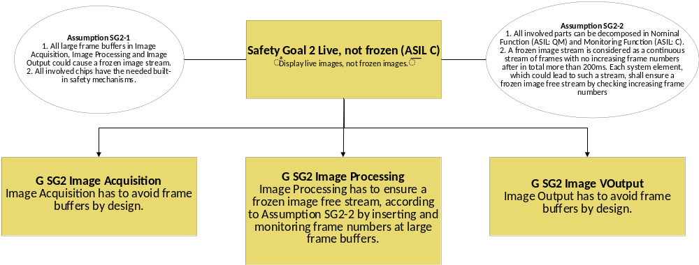
Figure 9: Fault tolerance time

As the functional blocks for image acquisition and image output shall not be able to store a complete video frame by design, only image processing is regarded further.

SG2 (Live, not frozen) – Image Acquisition – Data and Control Path

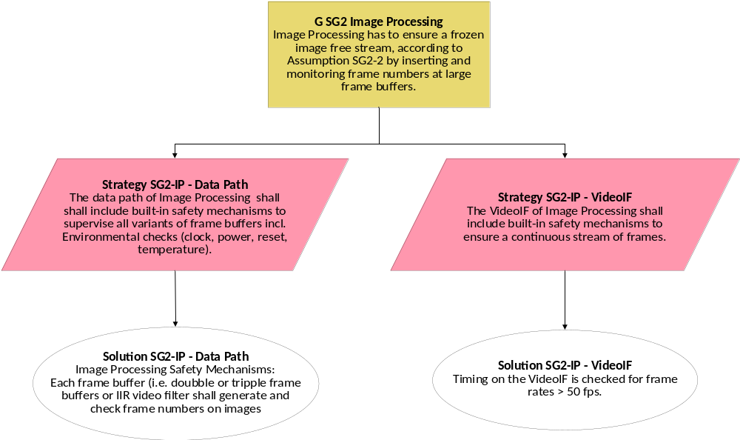
Figure 10: Fault tolerance time

SG2 – Functional Safety Requirements
The above GSNs lead to the following Functional Safety Requirements:

ID | Title | Description | ASIL
FSR 2.1
FSR 2.2
Table 9: Functional Safety Requirements for Safety Goal 2

Functional GSN – Safety Goal SG3 (Szene)

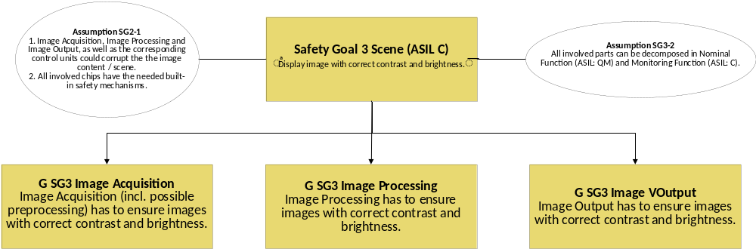
Figure 11: Fault tolerance time

SG3 (Scene) – Image Acquisition

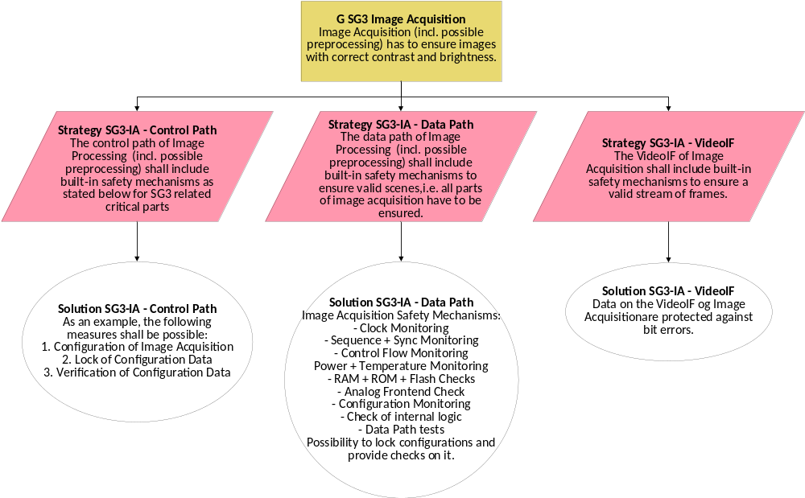
Figure 12: Fault tolerance time

SG3 (Scene) – Image Processing

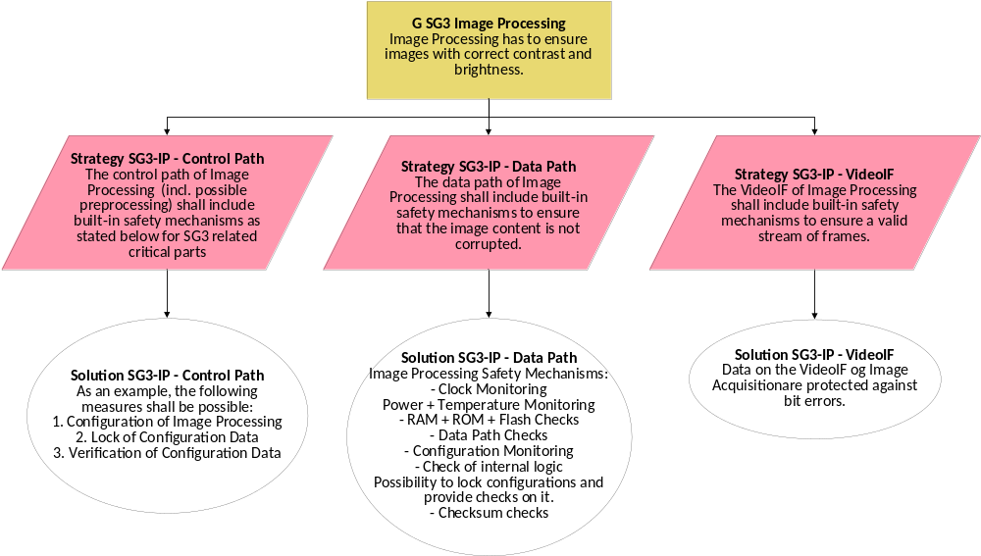
Figure 13: Fault tolerance time

SG3 (Scene) – Image Output

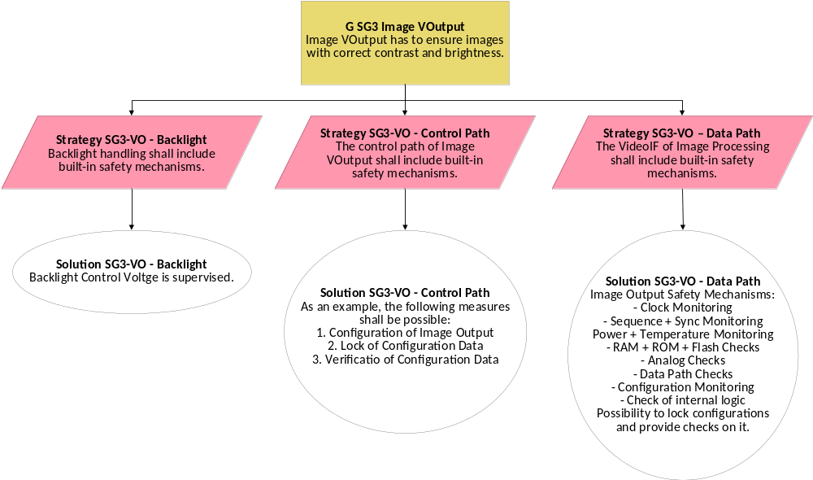
Figure 14: Fault tolerance time

SG3 – Functional Safety Requirements
The above GSNs lead to the following Functional Safety Requirements:

ID | Title | Description | ASIL
FSR 3.1
FSR 3.2
Table 10: Functional Safety Requirements for Safety Goal 1

Functional GSN – Safety Goal SG4 (Angle of view) – ASIL B

SG4 (Angle of view) – Image Acquisition – Data and Control Path

SG4 (Angle of view) – Image Processing – Data and Control Path

SG4 (Angle of view) – Image Output – Data and Control Path

SG4 – Functional Safety Requirements
The above GSNs lead to the following Functional Safety Requirements:

ID | Title | Description | ASIL
FSR 4.1
FSR 4.2
Table 11: Functional Safety Requirements for Safety Goal 1

Global Requirements

Functional GSN – Power

Power Monitor
The voltage for every component (SOW2::IA, SOW2::IP; SOW2::IO) shall be measured every 20 ms (to be clarified). The measured voltages shall be compared against predefined limits within FDTI. Exceeding of any boundary shall lead to entering the Safe State within FRTI.

Temperature Monitor
The temperature of every component (SOW2::IA, SOW2::IP; SOW2::IO) shall be determined every 20 ms (to be clarified). The determined values shall be compared against predefined limits within FDTI. Exceeding of any boundary shall lead to entering the Safe State within FRTI.

Clock Monitor
The time basis for the transmission between components and within a component (IA, IP, IO) shall be monitored every 20 ms. The decision whether a fault has occurred shall be made within FDTI. A detected fault shall lead to entering the Safe State within FRTI.

Functional GSN – Diagnosis

Functional GSN – Ethernet, SOME/IP

VOLVO – FSRs

The following FSR were given by VOLVO:

REMINDER:
- Sequence Monitoring
-
- Voltage level check for logical 1 or logical 0
Checksum checks

Safe State

Fault Detection

Fault Reaction

Enter Safe State
If one of the above Safety Goals is violated, the system (SOW1 + SOW2) shall enter the Safe State within 400 ms.

Definition Safe State
The Safe State is defined as no video output (black screen).

___________________________END OF FSC___________________________

System Architecture
This section provides a comprehensive overview on the basic system architecture as a basis for mapping initial solutions (SNx) to its elements. The aim is to achieve a comprehensive understanding of the system's functional mechanisms and possible interactions.

Basic System Architecture

Figure 15: Basic System Architecture

SNx Mapping to System Elements
These key components have to integrate the initial solutions (SNx) as follows (ASIL Level is shown in bracket):

Fault tolerance time & system transition to safe state
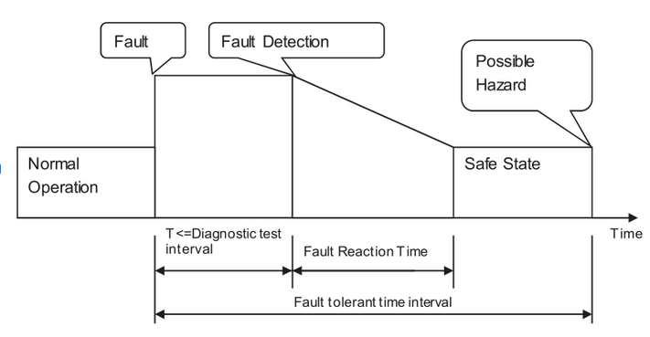
Figure 16: Fault tolerance time

Degradation of Functionality
In certain cases of errors inside the sensor, it could be a valid approach to signal the driver an error by a red outlined border but still display a live image with some degradation in functionality as long as the timing of the video data stream from the image sensor is still valid. However, such a concept should be detailed during the conception phase of the technical safety requirements.

Leaving the Safe State
INFORMATION: Leaving the safe state
After a Safe State is triggered, it is kept until shutdown of the system. (ASIL QM)

Technical Safety Requirements

